Software Requirements Specification Template

WAREHOUSE INVENTORY

Software Requirements Specification

V 1.0.0

September 03, 2022

Team Members:
SURESH GOPI TULAM
SRAVANI NALLA
SAMYUKTHA POTLA
CHAITANYAKRISHNA CHUNDIWAR
POOJA KUNTA

Submitted in partial fulfilment
Of the requirements of
CSIS 44-691 Graduate Directed Project 1

Revision History

Date | Description | Author | Comments
<date> | <Version 1> | <Your Name> | <First Revision>

Document Approval

The following Software Requirements Specification has been accepted and approved by the following:
Signature | Printed Name | Title | Date

Table of Contents

Table of Contents Page Number

- Introduction
  - Purpose
  - Scope
  - Definitions, Acronyms, and Abbreviations
  - References
  - Overview
- General Description
  - Product Perspective
  - Product Functions
  - User Characteristics
  - General Constraints
  - Assumptions and Dependencies
- Specific Requirements
  - External Interface Requirements
    - User Interfaces
    - Hardware Interfaces
    - Software Interfaces
    - Communications Interface
  - Functional Requirements
  - Use Cases
  - Class/Objects
  - Non-Functional Requirements
3.5.1. Performance
3.5.2. Reliability
    - Availability
    - Security
    - Portability
  - Inverse Requirements
  - Design Constraints
  - Logical Database Requirements
  - Other Requirements
  - Prototypes (for complete project)
  - Use Case Diagrams
- Design
4.1. ER diagram
4.2. GUI
- Analysis Models
4.1. Data Flow Diagram
4.2. Sequence Diagram
- Introduction
  - Purpose
The main objective of a warehouse inventory is to ensure that there is a constant supply of goods or raw materials to meet orders that you have without creating excess inventory. Warehouse inventory is a subset of inventory management and is focused on knowing which products are incoming and outgoing, as well as where each item is located.
  - Scope
The WIS is responsible for maintaining registered items, their quantities and alarming the manager and admin at lower stock. Moreover, it will be able to have a good check and balance in all branches associated with this system. This system will be a great deal for the owner and his/her customers and worker to perform their jobs in a very efficient way. This will be applicable to all stores having daily life’s needed items; thus it is a generic system.
- General Description
  - Product Perspective
Warehouse inventory software offers several key features to help you monitor the goods within your storage facilities and oversee inventory control. In some cases, warehouse inventory software is built into broader enterprise resource planning (ERP) software solutions; in other cases, warehouse inventory software serves as a stand-alone system. It is best to purchase a seamlessly integrated process if you want to manage your inventory across the entire ecosystem of your company. Inventory management software covers the acquisition, tracking, and shipping of products, ensuring you know what products are where at what time. They can also serve as forecasting tools, helping you to order items based on expected customer demand according to historical sales data. Some also offer alerts and notifications to improve the operational process of your warehouse, indicating when it is time to perform cycle counts.
  - Product Functions
Every warehouse moves things, stores them, keeps track of them, and sends them out regardless of the product. Our four primary types of equipment are storage, material handling, packing, and shipping, and barcode equipment as a result of these four activities.
  - User Characteristics
- Inventory Management. The module or feature is all meant to keep your essential warehouse functions centralized.
- Barcoding & Tagging.
- Inventory Tracking.
- Reporting Tools.

- Specific Requirements
  - External Interface Requirements
We might need real-time order status data from external private logistics
    - User Interfaces
- Login module
- Search results view from the inventory
- Order tracking
    - Hardware Interfaces
Mobile Operating System
- Android 7.0 and newer
- Inventory QR Code Scanner
  - Functional Requirements
    - Software Interfaces
- Android studio.
    - Communications Interface
In discussions, yet to decide.
  - Functional Requirements
Client
- Functionality of login/logout
- Privilege to Search for the products in inventory after successfully logging in.
- View the Results from the result list by scrolling.
- Ability to Choose the product from inventory and place an order.
- Choose to cancel the order or replacement
Admin
- Ability to Login into the application.
- Maintain the inventory and the products shown to the users.
- Pull up the orders details and their incidentals
- Has the privilege of approving returns and replacements
- Has the ability of tracking the orders and its status

  - Class/Objects
We will create the classes accordingly once we start implementation of the project.
  - Non-Functional Requirements
    - Performance
Warehouse performance measurement refers to the measurement of optimal use of storage space, customer relations activity, quality level, assets usage and costs.
    - Reliability
The reliability of an inventory system can be defined as its ability to complete all required processes before they are due.

Different ways to Ways to improve warehouse reliability:

Review your warehouse maintenance and operational plans.
- Plan for increased staffing needs.
- Use quality components and parts
- Set order deadlines earlier.

    - Availability
Warehouse availability refers to the amount of available space for storage, inventory preparation, and order fulfillment. To fully understand warehouse availability, it's important to make a clear distinction between theoretical storage capacity and working capacity. Inventory availability refers to whether a specific item is available for customer orders. Additional information provided by retailers may include the quantity available.
    - Security
A lack of warehouse security gives thieves an easy way to steal products and make a quick buck and no e-commerce business is immune to theft.

  - Design Constraints
There are three main types of constraints to consider when developing a feasible supply chain plan: Production Constraints, Flow Constraints and Storage Constraints. These three types of constraints should be determined at every point along the extended supply chain to ensure an optimal and feasible supply plan.
3.11 Use Case Diagrams
Below is the generalized use case diagram of warehouse inventory
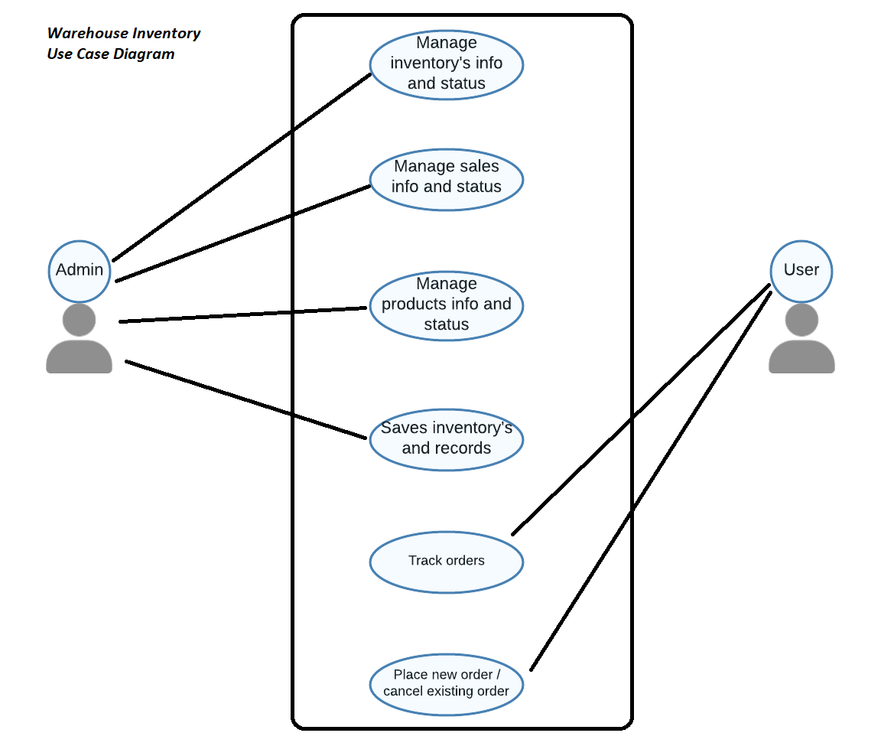

- Design
  - ER Diagram
ER model Design for Warehouse Inventory.
